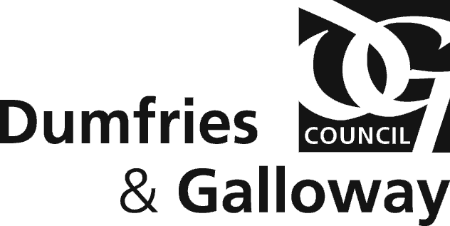

Environmental Health Dumfries and Galloway Council,
Militia House, English Street, Dumfries, DG1 2HR
Telephone 030 33 33 3000

[LB1 s50]

APPLICATION FOR FOOD HYGIENE CERTIFICATE
Licensing (Scotland) Act 2005

FULL Name and address of applicant
1

Postcode Telephone Email

Address of Premises
2

Postcode

Type of Licence Applied For
3
Specify whether Grant/Provisional Grant

Give full information relating to construction, layout, drainage, ventilation, lighting and water supply and also regarding provision of sanitary and washing facilities
4

Date Signature of applicant/agent

Postcode

Postcode

NOTES

Once completed, this form should be sent to either:-

Environmental Health, Dumfries & Galloway Council, Militia House, English Street, Dumfries, DG1 2HR or environmentalhealth@dumgal.gov.uk

Please make payment by calling Dumfries and Galloway Council, Environmental Health, on
030 3333 3000 by credit or debit card.

FEE of £160.00

