**The Dumfries Common Good Fishing Regulations 2023**

**IN LINE WITH THE CONSERVATION STATUS FOR THE RIVER NITH**

**THE 2023 SEASON WILL BE MANDATORY CATCH AND RELEASE FOR ALL SALMON**

**FISHINGS MAY BE RESTRICTED IN LINE WITH PUBLIC HEALTH ADVICE AT SHORT NOTICE.**

1. This ticket gives permission to fish with rod and line on waters controlled by Dumfries and Galloway Council in compliance with the following rules and regulations and the law. (please see map for boundaries). The fishing season opens on 25 February. The salmon season ends on 30 November.

2. The Council reserve the right to close any/all stretch of fishings by erection of an appropriately worded notice.

3. For the forthcoming season, there is a mandatory catch and release of all salmon. 1 sea trout or herling may be retained per day provided that it is not under 10 inches in length or over 3 lbs in weight. All sea trout and herling caught after the 6 October must be returned. All rainbow trout must be killed.

4. When fly-fishing, no lead lines or leaded hook are permissible. When using Rapala type lures the maximum length should not be greater than 90mm with no more than 2 treble hooks attached. The treble hooks should be no greater than size 4. When fishing with Rapala type lures no additional weight shall be allowed to be fixed to the line.

5. Bait fishing permitted 15th March onwards 1 hook shall be used.

6. Any water bailiff is authorised to forbid the use of any hook or tackle considered unsuitable and impound a ticket for unsporting or illegal practice.

7. No Float Fishing.

8. All pools should be fished in rotation, with anglers moving one metre downstream between casts.

9. No fishing during the hours of darkness until after 1 April.

10. All ticketholders **must** make statutory return of fish data by the end of the fishing season using the form provided, or online at [www.dumgal.gov.uk](http://www.dumgal.gov.uk). Failure to return fishing data (including NIL returns) may lead to a fine or declining your application in future years. To find the online form access www.dumgal.gov.uk and search under “fishing” thereafter follow the instruction.

11. Fish, fishing tackle, fishing ticket and identity card must be shown to any Police Officer, Council Official or water bailiff when requested. Identification and tickets (including digital) must be carried at all times when fishing.

12. Unsporting behaviour or foul/abusive language will be considered as a breach of regulations.

13. The use of natural prawns and shrimps (whether fresh or preserved dyed or natural colour) and any part thereof including any artificial guise of the same are banned as bait when fishing rod and line for salmon and sea trout in relation to the Council controlled beat on both the Rivers Nith and Cairn upstream of a line drawn across the River Nith from the house situated at 28 East Riverside Drive, Dumfries and the northeast corner of Kingholm playing fields, Dumfries.

14. Fishing tickets are issued subject to compliance with the adopted Nith Conservation Policy and Dumfries Common Good Fishing regulations and other regulations made by the Council from time to

time, whether during the currency of the ticket or otherwise

15. Sunday Fishing for brown trout and grayling only when legal to do so and during salmon fishing season.  Season Ticket holders permitted to Sunday fish with Season Ticket. Sunday fishing beat is identified separately on the fishing map.

16. After 30 Nov. A Grayling Only Permit is available to fish for Grayling on the waters controlled by Dumfries and Galloway Council and as identified separately on the fishing map.

# 17.Disqualification and penalties

a. Any police officer or water bailiff is authorised to impound a ticket for practices which are unsporting, in breach of these regulations or illegal. This shall have the same effect as Council Officer suspending the ticket. The Nith District Salmon Fishery Board shall thereafter forward a complaint in terms of section b below.

b. Where a ticketholder is:

* + charged with a criminal offence relating to fishing or wildlife crime, and/or
  + where two water bailiffs agree that a ticketholder has breached the regulations

the Fishery Board shall inform the Council within 5 working days of the incident. Upon receipt of a complaint a Council Officer shall investigate the complaint within 10 working days. If the complaint is upheld by the Council Officer, the Council Officer shall issue a notification to the ticketholder concerned informing them that their ticket is suspended as at the date of that notification. The investigation of any complaints made by the Fishery Board to the Council reported after the stated 5 working days shall be at the discretion of Council Officers.

c. The notification of suspension shall inform the Ticket holder that they have a right to lodge an appeal against the suspension within 10 working days of the date of notification. A meeting of the Dumfries Common Good Fund Sub Committee shall be convened within 20 working days of such appeal being lodged for the purpose of considering the suspension further and making a decision as to any period of disqualification or penalties. The ticketholder shall be issued with a letter informing them of the date of the appeal no later than 15 working days before the date of the appeal hearing.

d. A suspended ticket shall not be returned to the ticketholder until the Dumfries Common Good Fund Sub Committee considers the complaint and any appeal.

e. At the appeal hearing the Dumfries Common Good Fund Sub Committee shall consider the complaint and the appeal and thereafter shall either:

* + Revoke the suspension and return a proportion of the fee for that ticket, relating to the period of suspension; or
  + Uphold the suspension and disqualify the ticketholder; or
  + Continue the appeal hearing until the outcome of any related criminal prosecution is known

f. Disqualifications shall be in accordance with the following tariff:

* + A first disqualification will result in a minimum ban of the remainder of the portion of the current ticket, up to a maximum of five years.
  + A second disqualification will lead to a ban for a further between 5 and 10 years.
  + All third disqualifications would lead to a ban of a further 15 years.

g. From February 2020 there shall no longer be any ban for a period in excess of 15 years. Any outstanding bans for a period in excess of 15 years may be reconsidered, by the Dumfries Common Good Fund Sub Committee on a recommendation to the Council by the Director of the Nith District Salmon Fishery Board and the Committee of the Burgh Anglers Association, following an application from any banned individual.

h. The decision of the Dumfries Common Good Fund Sub Committee is final. There shall be no further appeals process.

**NOTE: Rules and Regulations will be vigorously enforced by the Director,**

**Nith District Salmon Fishery Board, and their staff.**

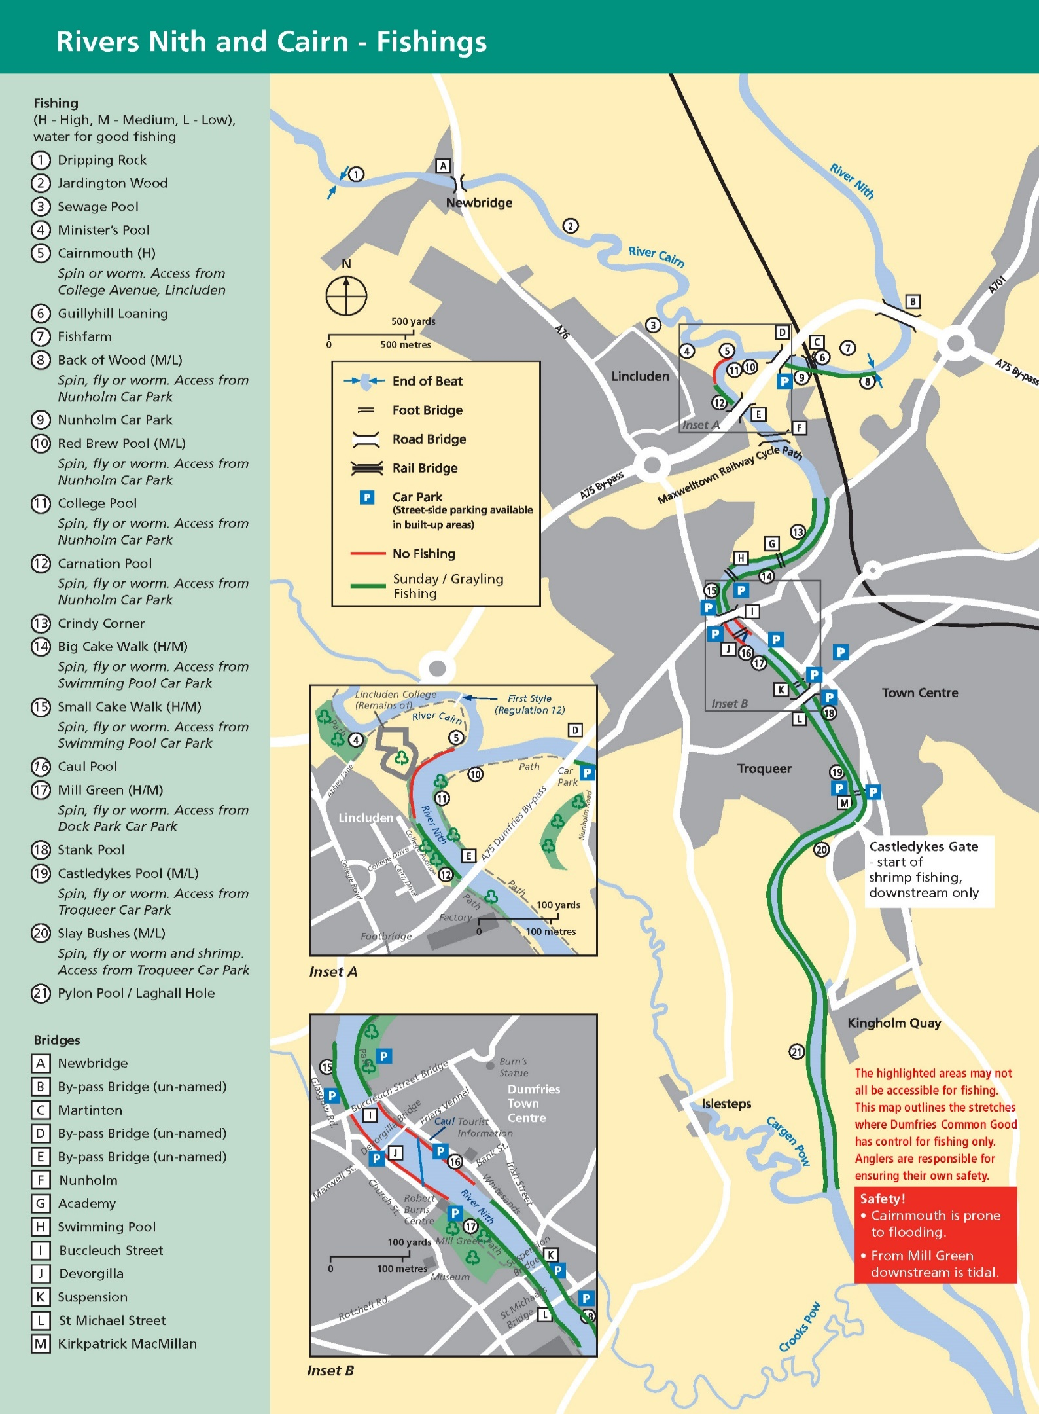

**USEFUL CONTACTS**

**Water Bailiff 07785 743663 Police 101/999**

**Dumfries and Galloway Council 030 33 33 3000**