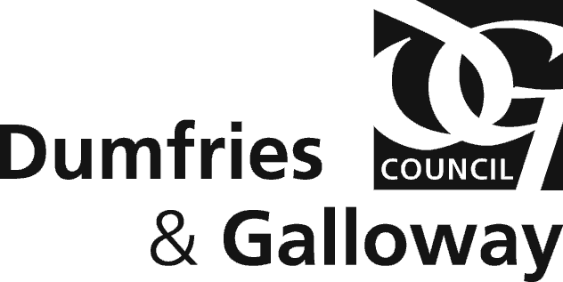

CIVIC GOVERNMENT (SCOTLAND) ACT 1982
APPLICATION FOR PERMISSION TO HOLD A PUBLIC CHARITABLE COLLECTION

EACH QUESTION MUST BE ANSWERED

1.
(a) Full name of applicant who must be the organiser of the collection.

D.O.B and PLACE OF BIRTH

(b) Address of applicant

(c) Business Hours Telephone No of Applicant Email Address of Applicant

(d) Name of Charity/Organisation

2. Particulars of charitable purposes to which proceeds of collection are to be applied.
(Full particulars should be given and, where possible, the most recent account of any charity which is to benefit should be enclosed).

3. Over which areas of Dumfries and Galloway is it proposed that the collection should take place?

AREA - NITHSDALE/ANNANDALE/WIGTOWN/STEWARTRY
If only collecting in certain areas of Dumfries and Galloway

TOWN/S -

State type of collection:

Street House to House

4. Date when collection is to take place

5. Approximately how many persons
is it proposed to authorise to act as collectors:

How will they be identified?

6. Is it proposed that remuneration should be paid out of the proceeds of the collection -

(a) to collectors? (b) to other persons?

If so, at what rates

7. Has the applicant or, to the knowledge of the applicant, anyone associated with the promotion of the collection been refused a licence or order under the Act, or had a licence or order revoked ?

If so, give particulars including name of licensing authority and date of refusal of revocation.

8. Has the applicant been convicted of any crime or offence?

YES NO

If so, subject to the provisions of the Rehabilitation of Offenders Act 1974, give details.

I declare that the particulars given by me on this form are, to the best of my knowledge and belief, correct.

Signature ………………………………………………..

Date………………………………………………………

Please return this form to:

Licensing
Dumfries and Galloway Council
Kirkbank House
English Street
Dumfries DG1 2HS

Or email licensing@dumgal.gov.uk

