Equality Monitoring form for  We need this information to make sure we are treating you fairly and with respect, and delivering the services you need. | 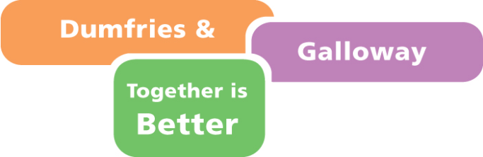
  Write the name and date of the event or survey here.
  Keep your writing within this box.

We will keep your information confidential. We will make sure that you cannot be identified through reports on the results of this survey.

Please tick () the relevant box in each section, or fill in the details as appropriate.

Section 1 Where do you live?
Please give the first three letters and numbers of your postcode.

If you don’t know your postcode, write the name of your nearest town or village here.

Section 2 What is your sex?

Male |  | Female
Intersex |  | Prefer not to say
My sex is not represented here. This is how I would describe my sex (please give brief details below)

Section 3 Have you ever identified as a transgender person?

Yes |  | Not sure
No |  | Prefer not to say

Section 4 What is your age?

0 to 15 |  | 55 to 64
16 to 24 |  | 65 to 74
25 to 34 |  | 75 to 84
35 to 44 |  | Over 85
45 to 54 |  | Prefer not to say

Section 5
How is your health in general?

Very good |  | good |  | Fair |  | Bad |  | Very bad

Please tell us which of the following affect you.

Physical disability
Deafness or partial hearing loss
Learning difficulty (eg, dyslexia)
Blindness or partial sight loss
Long-term illness, disease or condition
Mental health condition
Learning disability (eg, Down’s Syndrome)
Developmental disorder (eg, Autistic Spectrum Disorder or Asperger’s Syndrome
Prefer not to say
My condition is not represented here. This is how I would describe my condition (please give brief details below)

Section 6
What is your sexual orientation?

Bisexual |  | Heterosexual (Straight)
Gay or Lesbian |  | Prefer not to say

My sexual orientation is not represented here. This is how I would describe my sexual orientation (please give brief details below)

Section 7 What is your ethnic group?
Tick one box which best describes your ethnic group or background.

A White
Scottish
English
Welsh
Northern Irish
Irish
Gypsy or Traveller
Polish

B Mixed or multiple ethnic group
Any mixed or multiple ethnic group
(please write in)

C Asian, Asian Scottish or Asian British
Pakistani, Pakistani Scottish or Pakistani British

Indian, Indian Scottish or Indian British

Bangladeshi, Bangladeshi Scottish or Bangladeshi British

Chinese, Chinese Scottish or Chinese British

D African
African, African Scottish or African British

E Caribbean or Black
Caribbean, Caribbean Scottish or Caribbean British
Black, Black Scottish or Black British

F Other ethnic group
Arab, Arab Scottish or Arab British

G Prefer not to say

My ethnic group is not represented here. This is how I would describe my ethnic group (please give brief details below)

Section 8
What is your religion or belief?

Atheist or none |  | Hindu
Christian: Church of Scotland |  | Humanist
Christian: Roman Catholic |  | Jewish
Other Christian |  | Muslim
Baha’i |  | Pagan
Buddhist |  | Sikh

Prefer not to say

My religion or belief is not represented here. This is how I would describe my religion or belief (please give brief details below)

How to return the form to us

Thank you for filling in this form. Please return it in one of the following ways.

Please hand it to the people organising this event or consultation.

Send it by post to Planning and Performance Unit, Equality Monitoring, Council Offices, English Street, Dumfries, DG1 2DD.

