Dumfries and Galloway

Active Travel Strategy
2022 to 2032
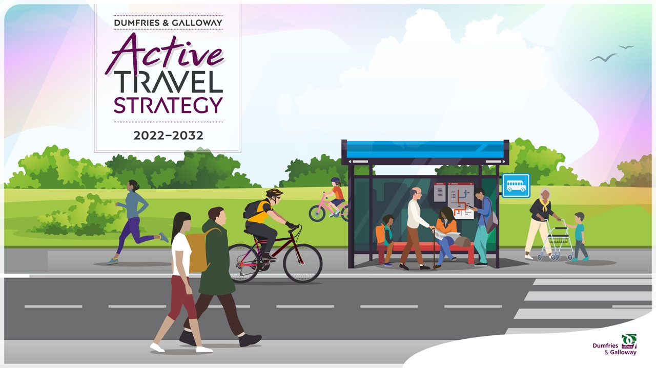

Easy Read

Copyright images © Photosymbols / Canva Prepared by Disability Equality Scotland

About this document
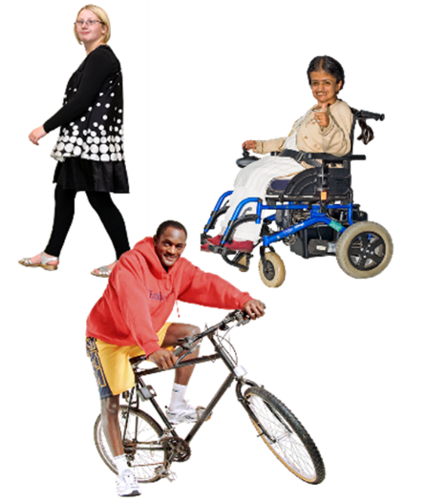 | This Easy Read document will tell you about the new Active Travel Strategy for Scotland’s area called Dumfries and Galloway.
Active travel means travelling by:

- walking
- wheeling
- cycling

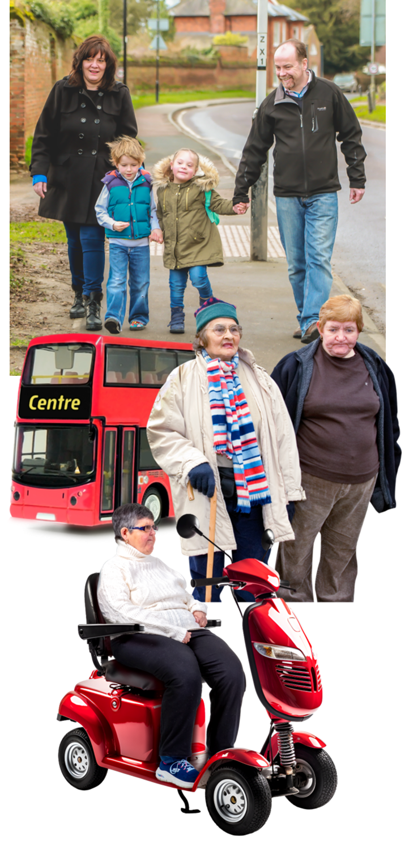 | In this document active travel also means:  - choosing journeys that need human physical activity  - using bikes or trikes  - using bikes or trikes that have been changed to make them easier to use  - using electric bikes or electric trikes  - using wheelchairs or mobility scooters  - journeys that use a mix of active travel and bus or train travel, or other types of travel
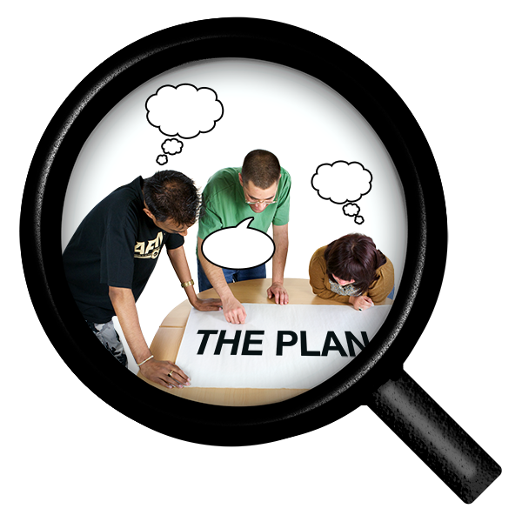 | A strategy is a plan of action for what we want to do.  This Active Travel Strategy is also called ATS2 for short.
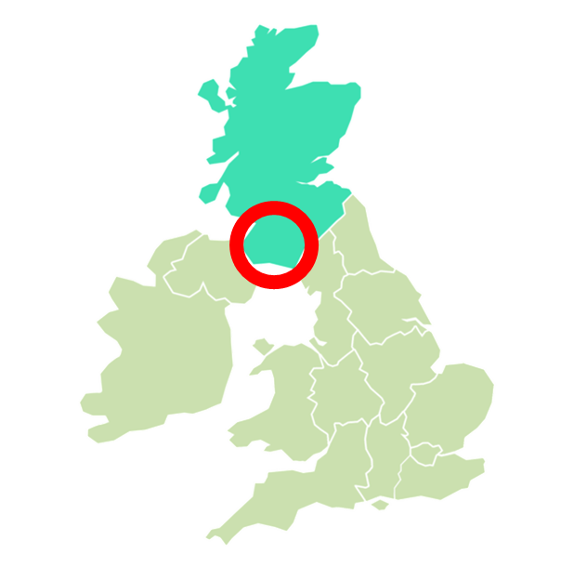 | Dumfries and Galloway is a council area in the south west of Scotland.

About the new Dumfries and Galloway Active Travel Strategy

This is Dumfries and Galloway’s second Active Travel Strategy.

It was agreed by the Council in October 2022.

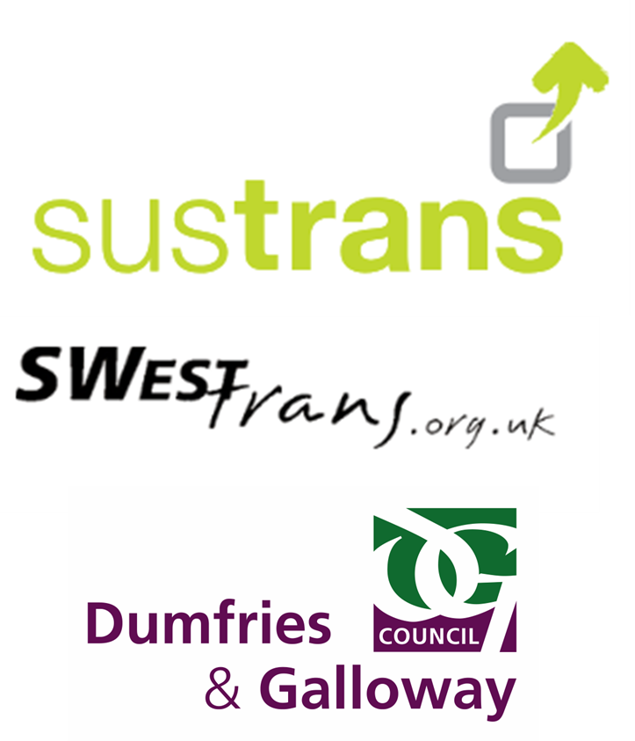 | This strategy was made together with other organisations, like:  - Sustrans  - Swestrans  - council services
This strategy will not work on its own.

It has a 10 year Delivery Plan with it.

And it will help to have more active travel happening in Dumfries and Galloway.

This strategy understands that everybody is different.

Different people have different needs.

This strategy will try to meet all the different kinds of needs.

The strategy was made by:

- looking at policies
- looking at other Active Travel strategies in the UK
- looking at how the first Active Travel Strategy went

 | - questionnaires and talks with our staff about active travel and the links between different council services
 | - looking at the facts and information about active travel
 | - asking people who live in Dumfries and Galloway how they want to see active travel made better

What we want to see for Dumfries and Galloway

 | We want to see Dumfries and Galloway being an active place.
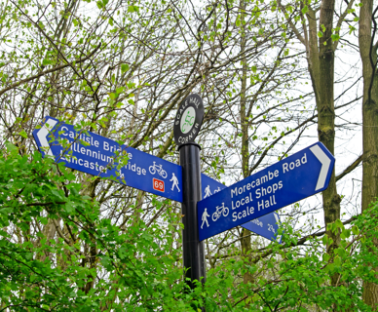 | We want Dumfries and Galloway to have routes to link different communities.  We want routes that are:  - accessible – everyone can use them  - reliable – easy to use and in good condition  - safe – not putting ourselves in danger
We want Dumfries and Galloway to use more active travel and cleaner transport
in its towns and villages.

Why it is good to active travel

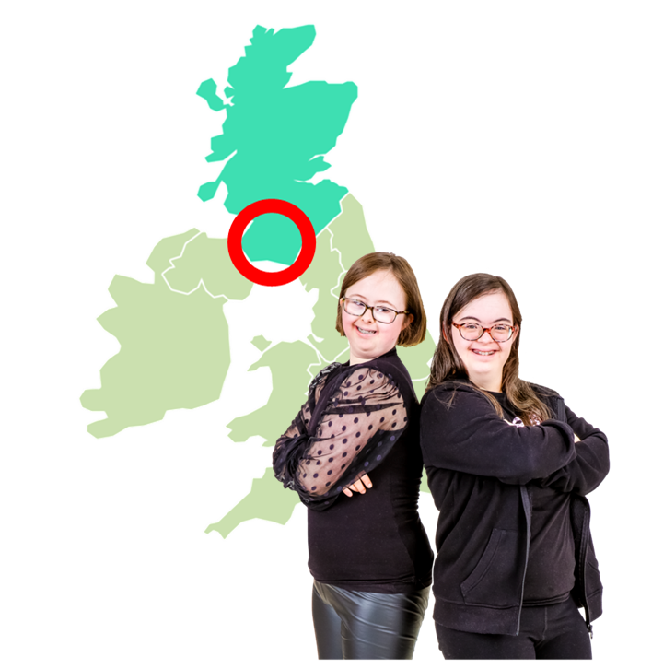 | More people in Dumfries and Galloway will feel happier and healthier.
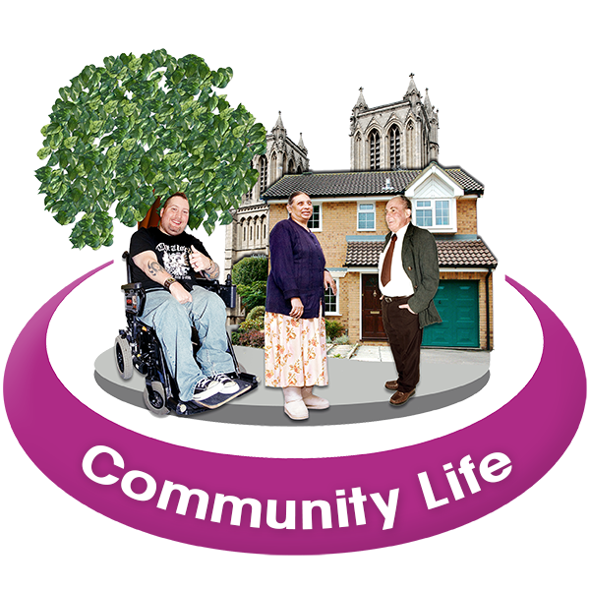 | Communities with active travel routes become better places to live, work and visit.
 | Walking and cycling are cheaper than using cars, taxis and other kinds of transport.
 | More jobs can be made.
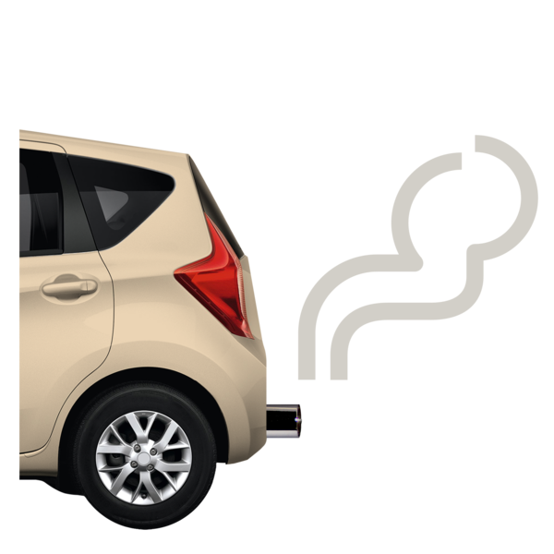 | When more people walk, wheel and cycle, less dangerous gases go into the air we breathe.  We are helping to stop climate change.
Climate change means our weather is changing and our planet is getting warmer every year.

We need to stop climate change because it is not good for our planet, people, animals or nature.

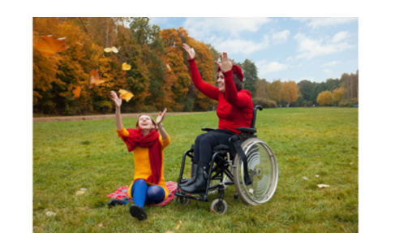 | When more people walk, wheel and cycle, there will be more clean air.  This will be good for people, wildlife and nature.
With more active travel, there will be less:

- traffic noise
- traffic jams

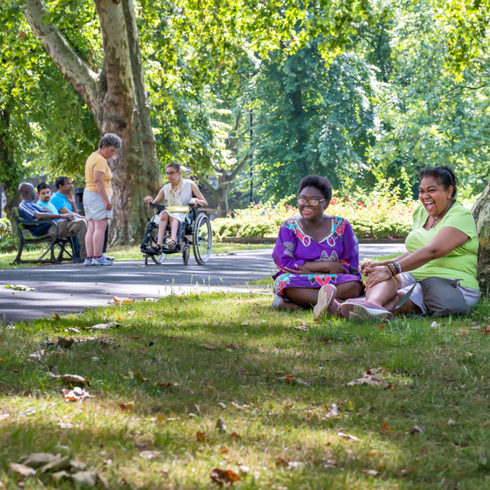 | More active travel means a future that is:  - fairer  - healthier  - greener

About our area

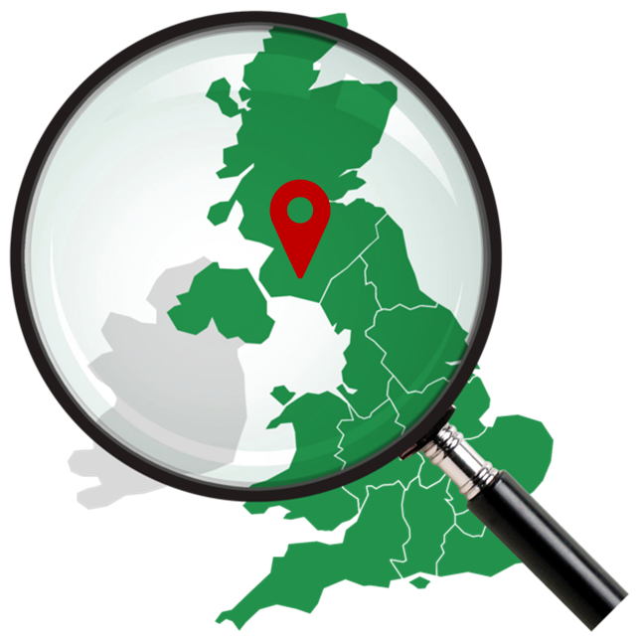 | Dumfries and Galloway Council is 1 of the biggest council areas in Scotland.  Lots of our villages and towns are far apart and hard to reach.
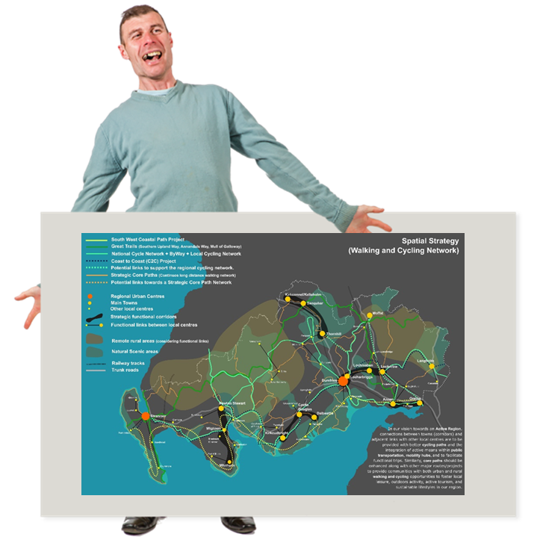 | We have made a special map of our council area.  The special map is called our Spatial Strategy.
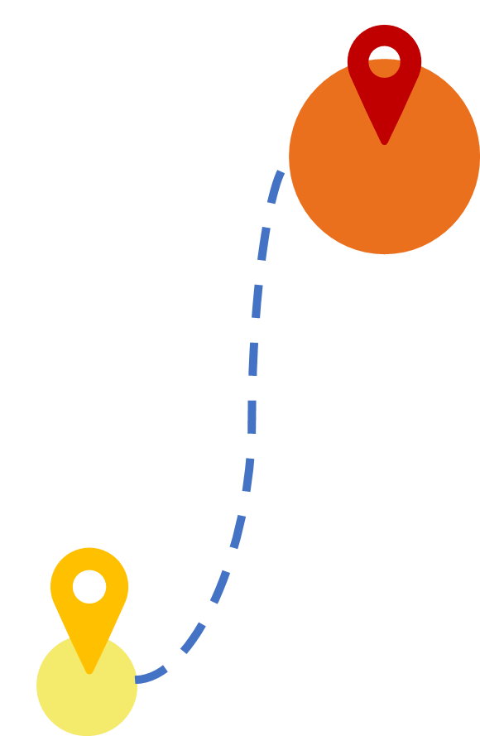 | It shows different paths, cycle ways and active travel routes.  The map also helps us to see:  - how some places can link to other places  - where we would like more active travel to happen
 | If you want to see the map, you can email NetworkStrategyTeam@dumgal.gov.uk

Our 10 aims

 | Our Active Travel Strategy has 10 aims.
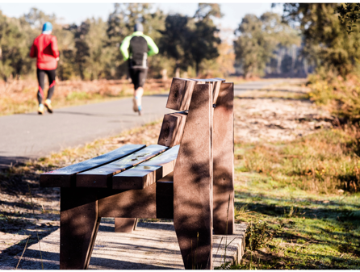 | 1. To make things like paths, cycle tracks, benches and signs better so that more people want to walk, wheel or cycle.
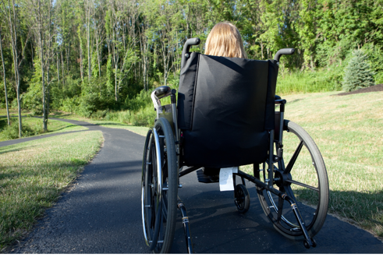 | 2. To make places and streets safer for people to walk, wheel and cycle.
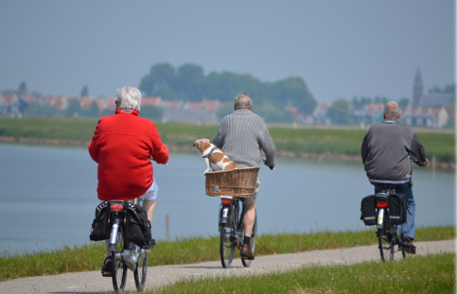 | 3. To help make walking, wheeling and cycling popular choices for short trips.
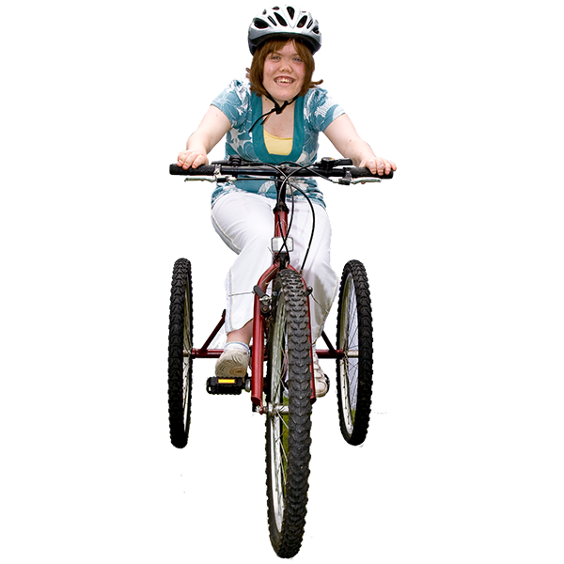 | 4. To help different kinds of people in Dumfries and Galloway so they feel confident about active travel.
 | 5. To work together with another plan called the Regional Transport Strategy.
 | 6. To help more people know about active travel for feeling healthy and happy.
 | 7. To help stop climate change by having more people walking, wheeling and cycling.
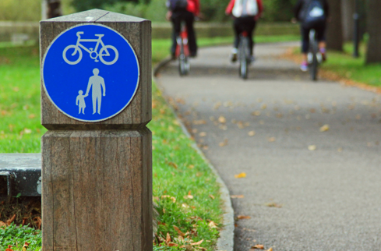 | 8. To have better paths between places.
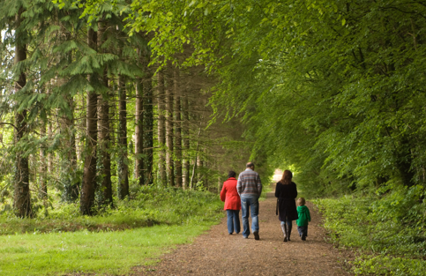 | 9. To make active travel important for:  - visitors and tourists  - people doing things like sports, eating out, going to parks when they are not working – this is called leisure time  - local businesses
 | 10. To see how our Delivery Plan is going and write reports on it.

How we will make the ATS2 work

We have a Delivery Plan to make the ATS2 work.

The Delivery Plan has nearly 40 actions that will happen.

The whole of Dumfries and Galloway Council will work together on the Delivery Plan.

We will collect information from organisations and surveys to see how well the strategy and the Delivery Plan are going.

