Section 2: Information about the land and rights requested
2.1 Please identify the land to which this asset transfer request relates.
You should provide a street address or grid reference and any name by which the land or building is known.
If you have identified the land on the relevant authority’s register of land, please enter the details listed there.
It may be helpful to provide one or more maps or drawings to show the boundaries of the land requested. If you are requesting part of a piece of land, you must attach a map and full description of the boundaries of the area to which your request relates. If you are requesting part of a building, please make clear what area you require. a drawing may be helpful.

Introduction
The RH Youth Organisation is a community-based, volunteer run charity (SCO49696) established in November 2019 to fill a gap in the range of activities that are offered to the children and young people in the community where we offer the provision of an Outdoor and Adventure Group and Theatre Group to children and young people aged between 4 and 17 years old. We aim to provide a safe, welcoming, and nurturing environment to enable our members to build confidence, social skills, life skills and independence.
Lockerbie Former Caravan Site (Glasgow Road, Lockerbie, DG11 2AR)
We are currently looking to acquire an area of land in close proximity to Lockerbie town centre. The layout of the land will need to provide space for such a building, including safe parking, adequate disabled access and situated within a prime location to enable the provision of community support and events.
The intention for the land would be to build a Community Complex that would consist of an activity centre, community recreation facilities and a headquarters building for the RH Youth Organisation that will have suitable space, storage and facility to enable an inclusive and equitable design - as well as an outdoor area to maintain our aims and rationale well into the future.
We are planning to build the complex in three stages. Initially, a simple structure, which would provide an adequate and appropriate base for all the activities provided by the organisation for our members and the community. We plan on acquiring a portacabin (known as the RHYO Activity Centre) to use as our base whilst funding applications and other pre-construction requirements are taking place. Within ten years, we hope to expand the complex in order to provide a wider variety of activities and services to the children, young people and local community.
The three stages are:
- YEAR 1-2- Temporary base such as a portacabin (RHYO Activity Centre) to be acquired and used. To also put on the land a shipping container for storage of equipment. We will also begin to implement our community programme, schools programme.
- YEAR 2-5- Community recreation facilities Community Implement the full community programme.
- YEAR 5-10- Headquarters – after all funding and construction phases are complete, we will build our main headquarters.
Site map-
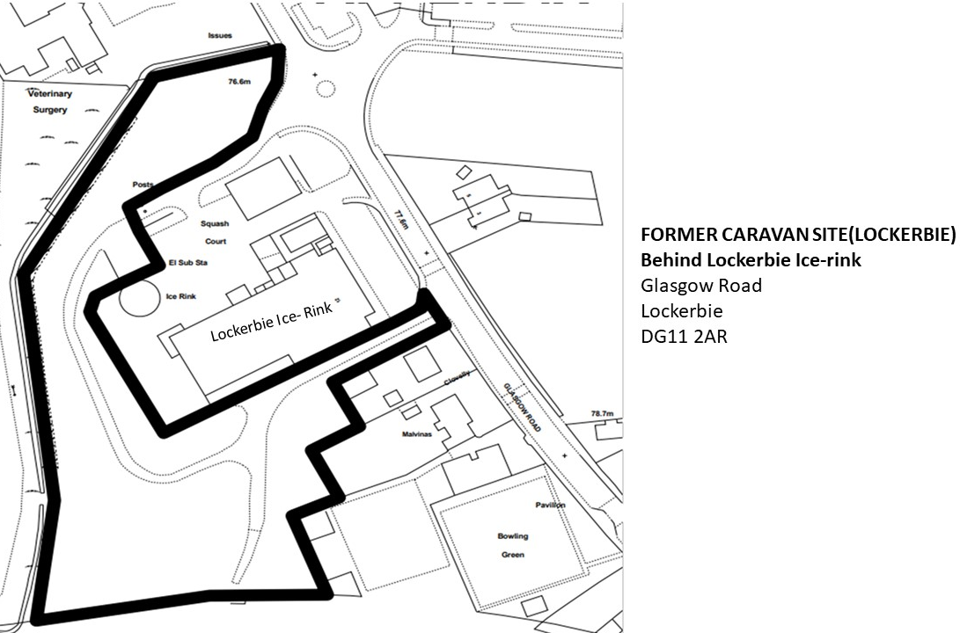
The areas marked in black are the boundaries of the land

Please find attached to scale in email.
Please note this will have a portacabin and container marked on it.

