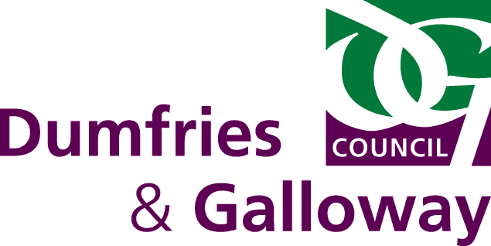
Animal Boarding Establishments Act 1963

Application for Licence
Business Name

Address of Boarding Establishment

Postcode of Boarding Establishment

Name of Applicant(s)

Address of Applicant

Landline Telephone Number

Mobile Telephone Number

Email Address

State whether dogs and/or cats are being boarded

Number of dogs being boarded
Number of cats being boarded
Is or has the applicant(s) ever been disqualified; (please insert √) |  | Yes | No
under this Act, from keeping a boarding establishment for animals
under The Pet Animals Act 1951, from keeping a pet shop
under the Protection of Animals (Amendment) Act 1954, from having the custody of animals
under section 28 F (1) and (2) of the Animal Health Act 1981
under section 40 (1) and (2) of the Animal Health and Welfare (Scotland) Act 2006
Give brief description of accommodation to be used for home boarding animals;

FEES:
Initial Grant or Renewal of licence £214.00

PAYMENT:
Payment can be made by the following –

Credit/Debit Card – by calling Dumfries and Galloway Council’s Trading Standards on 030 33 33 3000

I, the undersigned, do hereby apply for a Licence to keep a Boarding Establishment and do hereby declare the above particulars to be true and complete to the best of my knowledge and belief. I, also agree to the details provided in the shaded area will be published on Dumfries & Galloway Council’s Website.

Signature of Applicant

Date

Dumfries and Galloway Council Trading Standards
Militia House
English Street
DUMFRIES
DG1 2HR

TradingStandards@dumgal.gov.uk

030 33 33 3000

For Official Use Only
Fee Paid | Date Fee Paid | Date Receipt Issued

